January 21, 2016
Jesslyn Wilkinson
IT Training Specialist
Easy Interactive Software
Systems Integration and Innovation

How to use this document
This document is an IMIT Support Document. It identifies a new technological feature and explains the process to install and use the feature.
You may not need to read every page of this document. Use the TABLE OF CONTENTS to help you navigate around.
If this is your first time using this document type, read below to familiarize yourself with how to navigate this support document.
Type Style | Description of Application
ALL CAPS | Indicate a cross-referenced Heading. Press Ctrl+Click the heading to jump to the information.
Bold | Indicates what to click on your device. It may also emphasize important information.
Images | Align with the step by step instructions. Images may not perfectly match what you see on your device screen, but can be used as guides. A gold box indicates where you should click.
Underline | Indicates a hyperlink to an online resource. Use this to extend the support this document provides.

*Please Note: this manual will be less effective in printed format. The suggested format is to read this document on your screen, using Adobe Acrobat Reader.

Table Of Contents

How to use this document 1
Table Of Contents 2
Purpose 2
To Download the Software 3
Initial Start Up 10
Windows Firewall Alert 10
Home Menu 10

Purpose
This document orients you to downloading the Easy Interactive software found on all classrooms outfitted with an Interactive White Board (non-Panaboard).
This software allows you to interact with the display screen using a pen (touch capabilities in limited number of classes.) Using this pen, you can:
- Annotate on the screen, using the pen tools.
- Open and use software on the computer.
- Create whiteboard files, and annotate on these.
For resources on the tools available in the software, consult the Easy Interactive Quick Guide.

To Download the Software
To download the software, navigate to the Epson Support website location for Bright Link Interactive Projectors. The page displays the drivers for the hardware, and has two additional sections for the Utilities and Administrator Tools.
- Select the Utilities option. This will expand the options within this field.
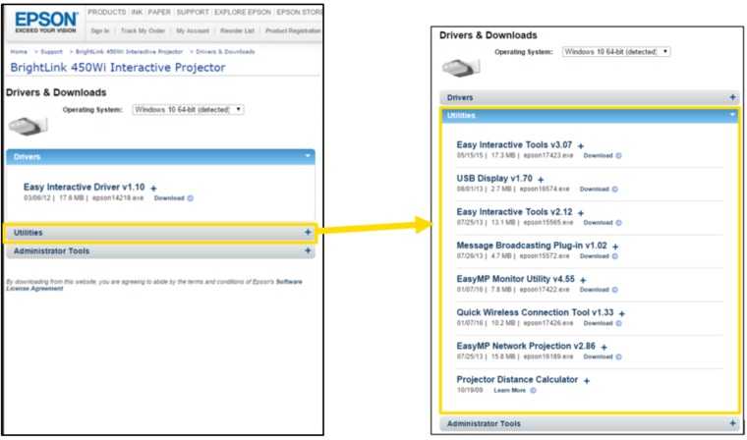
- Find the newest version of Easy Interactive Tools. It should be one of the first options. Click Download.
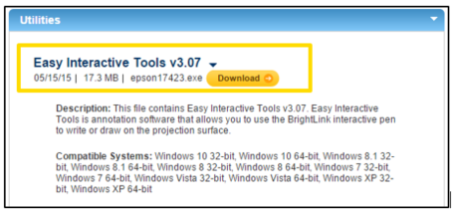

- A Sign Up & Download page will open. You do not need to fill in any of these fields. Simply click Download Now. Wait while the download begins.
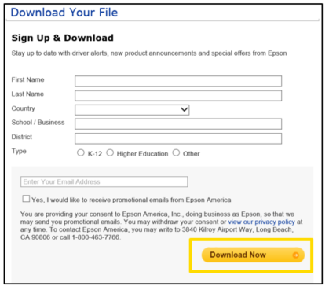

- Find your Browser type and follow the instructions.
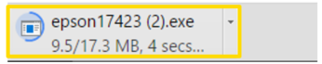
CHROME
Click on the downloaded file within the browser.
INTERNET EXPLORER
Choose Save, then Run in the window that appears in your browser.
FIREFOX
Click Save File. Then click the download when it opens in your Downloads area.
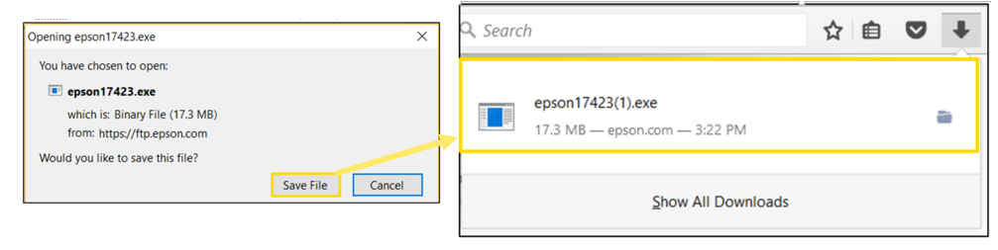

- No steps required. When the download begins, it will open a window, informing you that the process of installing will be automatic.
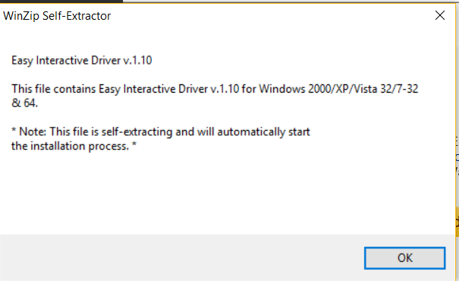

- Choose your language from the list. The software will be displayed in this language. Click Next.
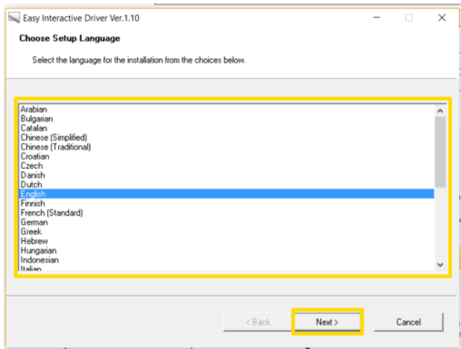

- On the Welcome to the Install Shield Wizard page, click Next.
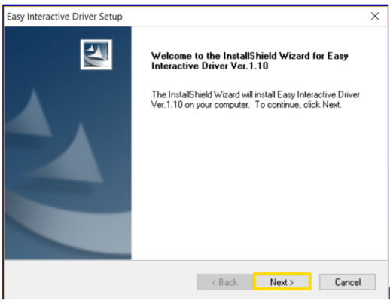
- Accept the License Agreement. If you do not accept, you will be unable to proceed. Then click Next.
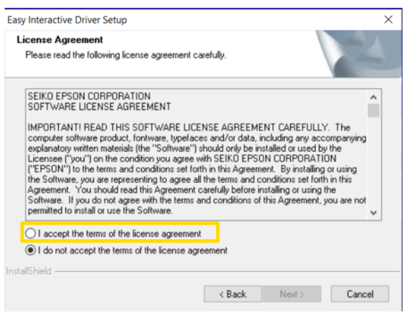
- If you prefer: Choose to Register to start up (The software will start when you turn on your computer) or Launch Easy Interactive Driver (not required).
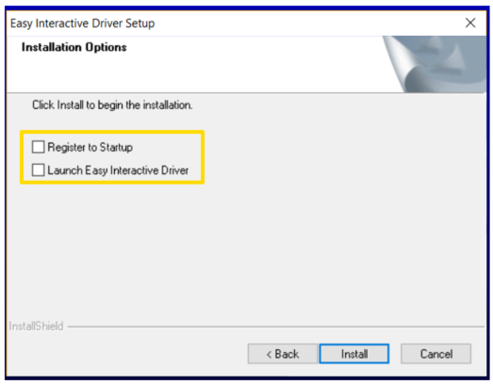
- Click Install.
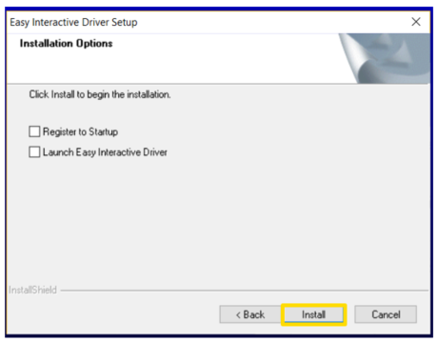

- No Action Required: Wait while the software installs.
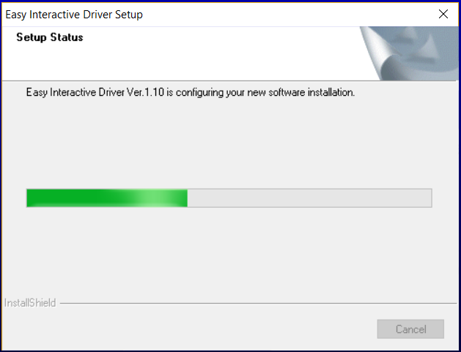
- The Install Wizard Complete window will open. Click Finish to complete the installation.
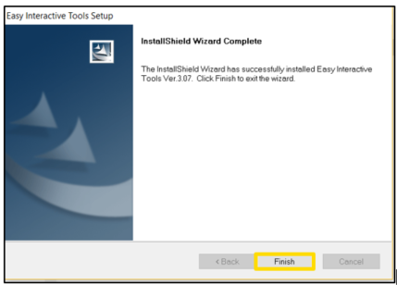
You are now able to locate your Easy Interactive software in your Windows Start Menu or Mac App Explorer (Command+Shift+A).

Initial Start Up
The following is intended to predict any issues the first time using the software. If you come across an issue, please contact the IT Service Desk.

Windows Firewall Alert
Some Windows users may notice a firewall alert on initial startup of their Easy Interactive software. If you see this, it is safe to select Domain Networks and click Allow Access.
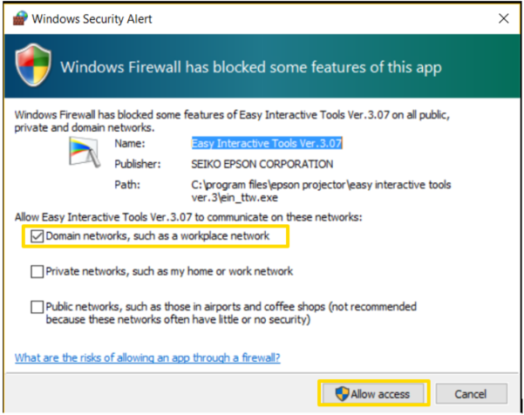

Home Menu
When first opening the software, the Home Menu will display. The Command Bar (top) and Annotation Bar (right) will be greyed out and unusable until this is closed.
To begin using the software, simply close the home menu by clicking the X. The Command and Annotation Bar will change to active. This allows you to begin using the pen or touch responsive screen. See Interactive White Board Quick Guide for additional support using the software.
