SLIDE ANNOTATION USING POWERPOINT
You can annotate on slides using features built into PowerPoint. These annotations can be saved to the file and shared with students.

TO ANNOTATE
The annotation features can be found in the lower, left hand corner of the full screened PowerPoint presentation. The icons are very faint in appearance.

TOOLBAR
The Toolbar lets you use:
- Arrows to navigate through the slides
- Pen Tool to write on the slide – clicking on this gives you an expanded menu list.
- View All Slides to quickly jump to a particular slide.
- Zoom allows you to focus in on a particular area of the slide.
- Ellipses giving more options – Hide Ink Markups, Exit the presentation or display different types of screen view.

PEN TOOL – EXPANDED VIEW
Once clicked, the Pen option gives the choice of Laser Pointer, Pen, Highlighter, Eraser, Erase all Ink on Slide, and the colour of your pen or highlighter.

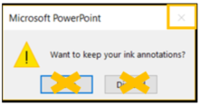

TO SAVE YOUR ANNOTATIONS
At the end of your presentation, you may want to save the document with annotations to share with your students. To do so, close the file. A prompt will appear, asking if you want to keep your ink annotations. DO NOT CHOOSE EITHER OPTION. Instead, choose the X, which will keep your annotations, but not save the file. In PowerPoint, choose File, Save As, and give the file a new name. Save it to your G Drive or another storage drive. This file can be uploaded to eConestoga, while preserving your original presentation

LIMITATIONS
Once you begin using annotation tools, the software assumes you want to continue to annotate. Your mouse stays a pen or highlighter, until you exit the presentation. Use the arrows in the Tool Bar to navigate through slides, or your presentation clicker.

SLIDE ANNOTATION USING EASY INTERACTIVE SOFTWARE
Easy interactive software integrates with PowerPoint. To use the Easy Interactive annotation, you must have Easy Interactive software open on your PC. It can be found in the Start menu, or on the desktop of the podium PC.

TO ANNOTATE
The annotation features can be found in the lower, right hand corner of the full screened slide. The default toolbar is the Simple toolbar, offering arrows to let you navigate to the next or previous slide.
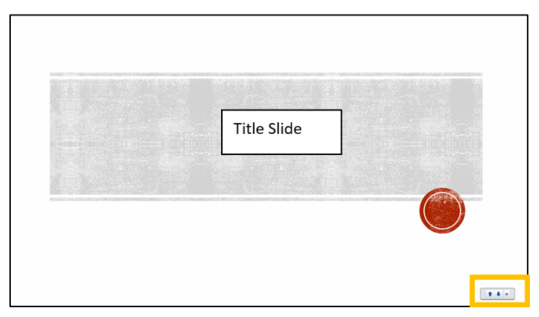
The Dock button (third button) lets you select which toolbar features are displayed: Simple or Full.

FULL TOOL BAR
Choosing the Full Toolbar lets you use:
- Arrows to navigate through the slides
- Selection Tool to select text or images.
- Pen Tool to write on the slide.
- Highlighter Tool – only yellow highlighter available.
- Change Pen Colour gives a pop out selection of colours.
- Eraser – erase specific annotations
- Erase All – remove all annotations from the screen.

LIMITATIONS
The annotations do not save to the PowerPoint file, just with the screen appearance. This means you will not be able to save any notes or information you have added to the slides using this method of annotation.
The annotations also stick around. Before advancing to the next slide, you would need to erase your annotations, or else they will appear over top of your next slide.

