Getting Oriented to SharePoint Navigation
This is the “top navigation” of a SharePoint site, and the first navigation menus to become familiar with. SharePoint uses an interface (look and feel) similar to Office 2013, where all text is clickable, and there will be few icons.
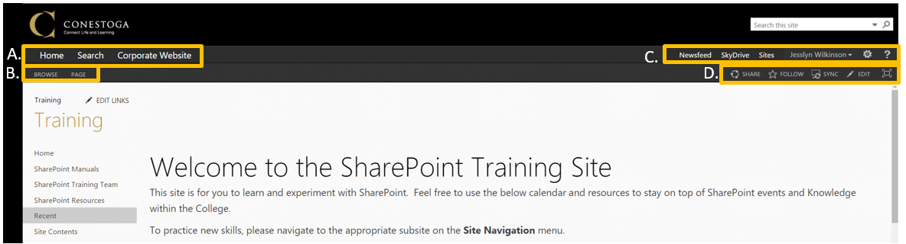

Conestoga Farm Navigation
These options control your movement between different departments’ sites.
- Home will jump to a list of all the Featured Departmental Sites at the College.
- Search to search across all the sites. (Currently this function is not in use.)
- Corporate Website will jump to the Conestoga College Corporate Site.

Page Actions
Some of these features are conditional on your Permissions Level.
- Page displays a ribbon of the actions you can take to edit this page. If you have Visitor permission level, you will not see this option.
- Browse closes the ribbon.

Personal Profile Navigation
These features are visible to all SharePoint users.
- Newsfeed jumps to your profile, where you can see updates on documents and sites you follow.
- SkyDrive jumps to a personal storage drive, like your G: Drive. It can act as a supplemental storage, if you need it, but should not replace your use of your G: Drive.
- Sites will list all the sites you decide to follow.
- UserName allows you to view and edit Profile Information (About Me), or to Sign Out.
- Settings provides options for working with the Site. What you see in this menu is conditional on your Permissions Level.
- ? opens a Help window, where you can search an area in which you need support.

Quick Actions
Some of these features are conditional on your Permissions Level.
- Share allows you to share the site with another user. If you are allowed, you can set that users Permission Level, and notify them via email.
- Follow will add this site to your Sites list, and give updates about Site changes in your Profile NewsFeed.
- Sync will sync a shortcut to a Document Library on this page to your Desktop. This feature is unavailable currently.
- Edit allows you to edit the page, by adding apps or text.
- Full Screen will remove the Site Navigation menus from view. To bring them back, select Full Screen again.

